**IOT ENABLED HOSTEL ATTENDANCE SYSTEM**

**A Project Report**

***Submitted by:***

**YASH RAJ PANDEY (191B295)**

**SAMARTH DUBEY (191B304)**

**ARYMAN TRIPATHI (191B309)**

***in partial fulfillment for the award of the degree***

***of***

**BACHELOR OF TECHONOLOGY**

**IN**

**COMPUTER SCIENCE AND ENGINEERING**

***at***



**JAYPEE UNIVERSITY OF ENGINEERING & TECHNOLOGY**

**GUNA, MADHYA PRADESH (INDIA) – 473226**

**DECLARATION**

I hereby declare that the project entitled “IOT Enabled Hostel Attendance System” submitted for the B. Tech. (CSE) degree is my original work and the project has not formed the basis for the award of any other degree, diploma, fellowship or any other similar titles.

**Signature of the Student**

**Place:**

**Date:**

**CERTIFICATE**

This is to certify that the project titled “IOT Enabled Hostel Attendance System” is the bona fide work carried out by YASH RAJ PANDEY(191B295), SAMARTH DUBEY(191B304), ARYMAN TRIPATHI(191B309), students of B Tech (CSE) of Jaypee University of Engineering and Technology, Guna (M.P), during the academic year 2022-23, in partial fulfillment of the requirements for the award of the degree of Bachelor of Technology (Computer Science and Engineering ) and that the project has not formed the basis for the award previously of any other degree, diploma, fellowship or any other similar title.

**Signature of the Guide**

**Place:**

**Date:**

**ABSTRACT**

The project we are making is IOT Enabled Hostel Attendance System which will read the barcode present on the ID card of every student at JUET, and it will be used to mark the attendance of students in hostels, which will make it easier for warden and superintendent very easy and can help in reducing manual labor required in the hostels.

Technology we have used:

* Flutter
* MySQL
* Flask
* Python3

**ACKNOWLEGEMENT**

We have invested a lot of time and efforts in completion of this project but this project would not have been possible without the kind support of various individuals and organizations, we hereby extend our sincerest gratitude to all of them. We are highly indebted to our faculty Mrs. Babita Tiwari. We would like to thank her for constant guidance and supervision. We would like to thank JUET for providing us with such supportive and innovative environment facilities and lending us their support whenever required.

We will also like to thank the whole as an organization for providing us with such opportunities. At last, we all will like to thank and congratulate our fellow project members for their hard-work and dedication.

**TABLE OF CONTENT**

**1. INTRODUCTION**

1.1 Problem Definition

1.2 Project Overview/Specifications

1.3 Hardware Specification

1.4 Software Specification

**2. LITERATURE SURVEY**

2.1 Existing System

2.2 Proposed System

2.3 Feasibility Study

**3. SYSTEM ANALYSIS & DESIGN**

3.1 Requirement Specification

3.2 Design and Test Steps

3.3 Testing Process

**4. RESULTS / OUTPUTS**

**5. CONCLUSIONS / RECOMMENDATIONS**

**6. REFERENCES**

1. **INTRODUCTION**
   1. **Problem Definition**

The project we are making is about a Hostel Attendance System with the help of IOT, or as we call it IOT Enabled Hostel Attendance System. It includes reading barcode printed on ID card of students at JUET which contains the enrollment number of respective student. We will use a barcode reader to mark the attendance of students in hostels which is done by pen and paper mode till now.

* 1. **Project Overview/Specifications**

Project Overview are the salient features of the Project. It consists of the various new and updated tweaks and features we’ve curated for our users, and the productivity boost it will provide for the same.

* Login and Sign-Up Page for the Students.
* Semester Information and Hostel Allotment Information of the same.
* Admin Access to all the Wardens.
* Students Information Update Page for the Wardens.
* Individual Level Access according to the Role Assigned.
* Centralized Database for all the Students.
* Ease of Access to all the Wardens for leave and emergency vacations.

**1.3 Hardware Specifications**

Hardware Specifications represent the minimum hardware requirements required for smooth working of our project. Hardware Requirements cover everything from basic computing hardware to advance software needed in order to access our code and be able to execute the same as well.

|  |  |  |
| --- | --- | --- |
| **Component** | **Minimum** | **Recommended** |
| Processor | 1.9 gigahertz (GHz) x86- or x64-bit dual core processor with SSE2 instruction set | 3.3 gigahertz (GHz) or faster 64-bit dual core processor with SSE2 instruction set |
| Memory | 2 GB RAM | 4 GB RAM+ |
| Display | Super VGA with a resolution of 1024 x 768 | Super VGA with a resolution of 1024 x 768 |
| Android Version | 9.0 | 12.1 |

**1.4 Software Specification**

A software requirements specification (SRS) is a document that describes what the software will do and how it will be expected to perform. It also describes the functionality the product needs to fulfill all stakeholders needs.

* Any windows-based computer.
* SQLite3 for DBMS.
* Visual Studio Code (for running the software).

1. **LITERATURE SURVEY**

**2.1 Existing System**

The current system which our hostels use is pen and paper method for marking attendance of each student. The hostel superintendent sits in the office and students go in one-by-one and mark themselves present, which is very hectic for both the superintendent and the students.

**2.2 Proposed System**

The system we propose is that all the students already have an ID card which has a barcode on it. We just need to install a barcode reader in every hostel and a computer system as well. In this case computer system is already provided to superintendent of every hostel. The barcode reader will read the barcode on ID cards and mark the students present with time stamp and their room number and all the relevant data.

**2.3 Feasibility Study**

The apparatus required is not that much expensive and visitors room in every hostel have a large glass window in which we can install a barcode reader on the inside which can read through the glass just fine.

**2.3.1 Financial Feasibility**

This is a simple barcode reading software connected to a database, which doesn’t add up any cost. The only cost is of a barcode reader, which is a one-time investment. There is absolutely no server costing or maintenance cost.

**2.3.2 Technical Feasibility**

This project uses the following software:

* Visual Studio Code
* SQLite3
* Adobe XD for wireframe mockups
* Figma for the UI flow

*Each of them is available for free and skills required are manageable.

**3. SYSTEM ANALYSIS AND DESIGN**

**3.1 Requirement Specification**

**Visual Studio Code:** Visual Studio Code is a streamlined code editor with support for development operations like debugging, task running, and version control.

**SQLite3:** Used to create a database, define tables, insert and change rows, run queries and manage an SQLite database file.

**Python:** The whole script of barcode reading, storing the data in database, fetching the data, updating the data is done by using libraries in python and implementing in our code.

**3.2 Design**

A test design is developed to portray the test effort, in order to give project and test personnel a mental framework on the boundary and scope of the test program. Following test analysis, the test team develops the test program design models.

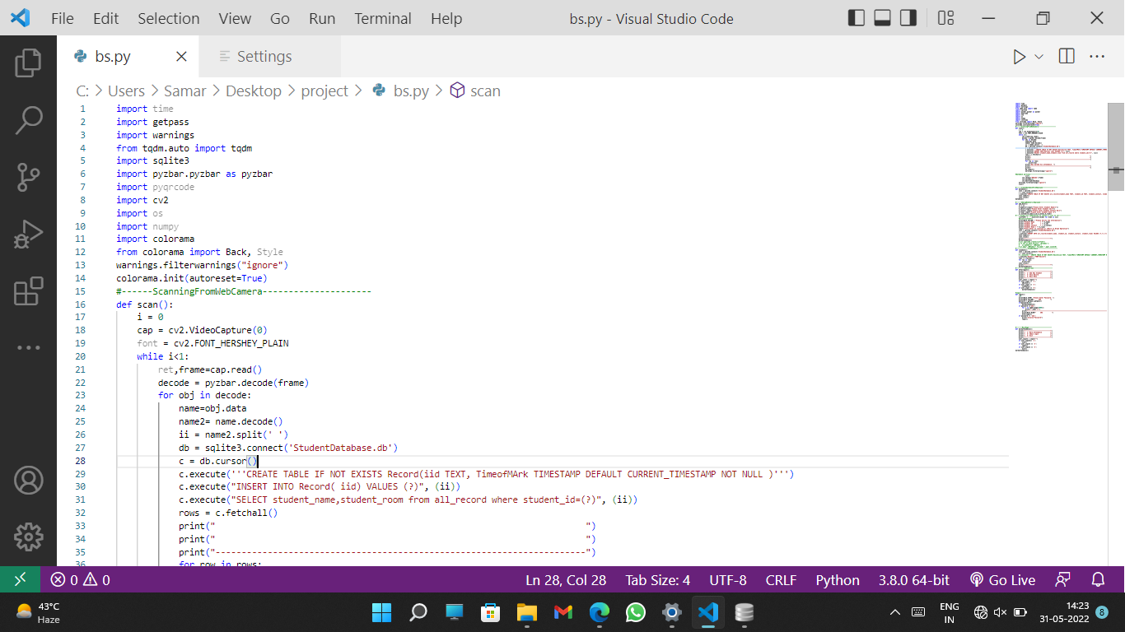

Fig 3.2.1 (Code Snippet)

**3.3 Testing Process**

Testing is an integral component of the software development process. It entails a comprehensive assessment of a software to ensure it meets your client's requirements and goals. The primary goal of testing is to identify all the defects and errors in the software before the implementation phase.

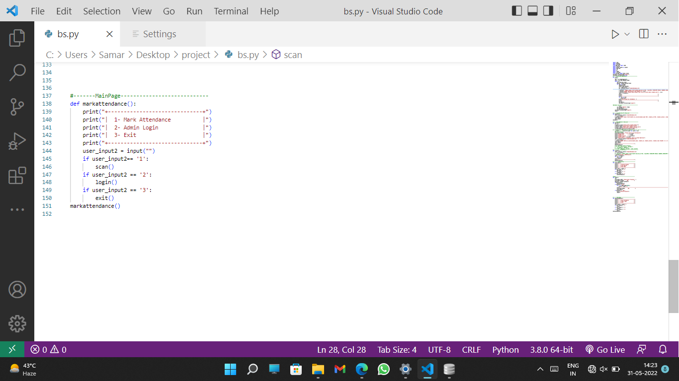

Fig 3.3.1 (Admin Screen)

1. **RESULTS/OUTPUTS**

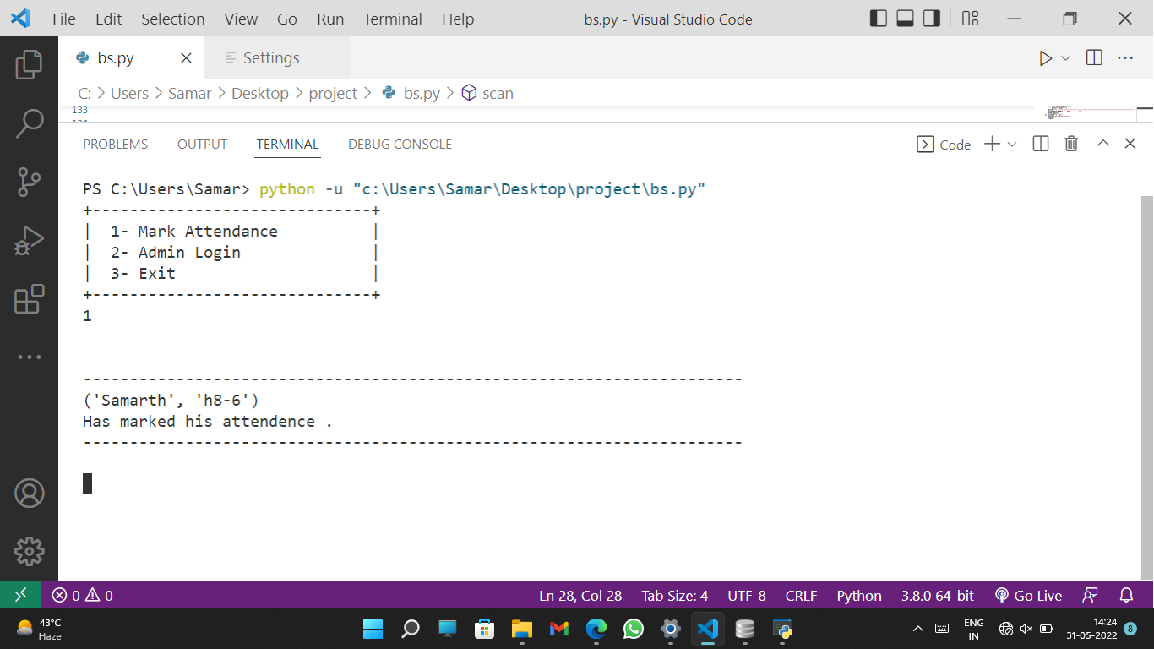

Fig 4.1 (Code Flow)

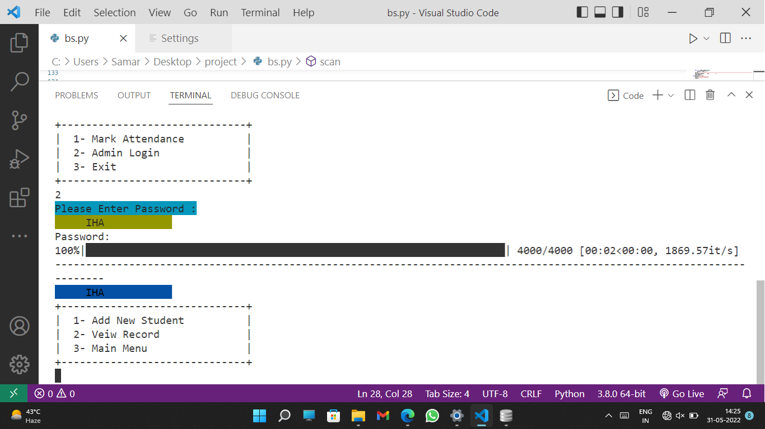

Fig 4.2 (Code Flow)

1. **CONCLUSION/RECOMMENDATION**

The conclusion of this project that we did in 6th semester is by the end of the semester the software will be fully functional and ready to use in day-to-day attendance in our hostels.

This software is created for our university i.e., JUET and will only be used here.

1. **REFERENCES**

We went through the following websites and articles to cover up the technology needed for the IHA Project and furthermore redundancies. We also went over the documentation of the following languages.

* Python3 Documentation
* TensorFlow Module
* OpenCV Module
* PYZBAR
* Academia
* Medium
* Trained Datasets of ID Cards